Facts for the trade press
Efficient surface finishing of high-value work pieces
Walther Trowal presents new machine at IMTS
Gentle finishing of extremely hard surfaces
Overlapping rotational work piece movement is the basis for even, all-around surface finishes
Haan, Germany, August 7, 2018 At this year’s IMTS Walther Trowal is introducing the new drag finisher M-TMD 6M for treating high-value components that require a first-class surface quality. The new drag machines will place a mirror polish on the hardest materials – even on ceramic components. With these machines the costs for polishing can be reduced to a fraction of the costs for manual surface grinding and polishing. But even more important: They ensure absolutely repeatable, high-quality finishing results within an extremely narrow tolerance band.
Walther Trowal developed these new machines specifically for treating high-value components requiring extremely careful handling for the complete finishing process. For example, they are utilized for finishing the surface of turbine blades, impellers for turbo chargers, precision components for pumps and compressors as well as for orthopedic implants.
The new drag machines of the M-series have a carousel with multiple rotating workstations. In turn each workstation is equipped with spindle heads containing several spindle drives onto which the work pieces are attached with special fixtures. In addition, these machines also contain a stationary work bowl filled with grinding or polishing media. As the work pieces are “dragged” through the stationary media mass, the simultaneous rotational work piece movement by carousel, workstations and spindles creates different overlapping patterns, which ensure an even and intensive coverage of the complete work piece surface.
Christoph Cruse, director of sales at Walther Trowal, foresees a big demand for these machines at some of his customers who produce delicate, high-value components. He explains: “With our new machines we want to assist the manufacturers of work pieces that must receive the best possible surface finish, and where even the slightest surface flaw or scratch might cause them to be scrapped. Furthermore, we target parts where deviations from the dimensional specifications of a few thousands mm can be a detrimental. The M-TMD drag finishers with their perfect surface coverage open brand-new possibilities for finishing such work pieces.”
Die M-TMD 4 drag finisher is equipped with four work stations and can process 12 parts in one single batch; the M-TMD 6 – with six work stations allows batch sizes of up to 18 pieces.
At this year’s IMTS Walther Trowal also displays a range of mass finishing equipment including rotary vibrators, the MV multi vib vibrators and a high-energy centrifugal disk finishing machine.
One drag finishing success story:
Polishing of the extremely wear resistant ceramic coating on orthopedic implants
One example for the successful use of the new drag finishers is a process, specifically developed by Walther Trowal, for polishing of knee femorals made from a chromium-nickel alloy, which are covered with a ceramic coating applied with a special vapor deposit method. To date these parts had to be finished manually in time consuming multiple steps with the risk of high quality fluctuations.
After a pre-grinding step the ceramic coating is polished in the new M-TMD drag finisher with a polishing medium specifically developed for this application. The result: Although the ceramic coating is extremely hard, the drag finisher produces a very smooth, shiny and highly wear resistant finish from the initially rough surface condition. The new coating extends the fatigue life of the implants from to date about 20 up to 30 years!
In developing this process Walther Trowal took an entirely new approach. Instead of using relatively soft polishing materials the company is adding an extremely hard substance to the polishing medium, namely diamond powder.
Christoph Cruse explains the advantages of the new process as follows: “Soft materials can be polished relatively easily. But the manual polishing of extremely hard coatings has been extremely difficult, especially because an even surface finish is essential for the functionality of the component. In the case of vapor deposit coating, with a layer thickness of just a few microns, it is essential not to remove too much of the coating material from the part surface. With the M-TMD drag finishing technology and the new polishing media we have resolved this difficulty: The finish is absolutely even on the entire surface area of the implants.”
Walther Trowal at the IMTS 2018
September 10 – 15, 2018, Chicago, IL, USA
North Building, Level 3, Booth 236609
The technical details
In standard drag finishers the work pieces are directly mounted to the workstations and “dragged” through the stationary media bed producing an extremely high processing intensity. This method is more than adequate for most work pieces and produces excellent finishing results.
The new M-TMD systems allow one additional rotational movement, namely that of the spindles mounted to the workstations. The multi-spindle heads on the workstations can be also be angled allowing the adaptation of the media coverage on the work piece surface to different work piece geometries.
All process steps, from cut-down, over surface smoothing to the final polishing, take place in the same machine, without having to remove the work pieces from the spindles.
The new drag finishers are suitable for dry as well as wet processing. In wet processes for cut-down, surface smoothing and, occasionally, for polishing, special finishing compounds are used. For the targeted edge radiusing within a tolerance range of a few thousands mm, like for example for tungsten carbide drill bits or milling tools, dry grinding media are utilized. Dry processing is also used for high gloss polishing with special pastes and polishing media.
Contact in Germany:  Walther Trowal GmbH & Co. KG  Georg Harnau  Rheinische Str. 35-37  42781 Haan/Germany  Tel: +49.2129.571-209  Fax: +49.2129.571-225  www.walther-trowal.de  g.harnau@walther-trowal.de | Contact for the editor:  VIP Kommunikation  Dr.-Ing. Uwe Stein  Dennewartstraße 25-27  52068 Aachen/Germany  Tel: +49.241.89468-55  Fax: +49.241.89468-44  www.vip-kommunikation.de  stein@vip-kommunikation.de
Contact in the United States:
Walther Trowal LLC
Ken Raby
Vice President & General Manager
4540 East Paris Avenue SE, Suite F
Grand Rapids, MI 49512, USA
Tel.: +1.616.455 8940
Fax: +1.616.871 0037
www.walther-trowal.com
k.raby@walther-trowal.com

Photos:
Download von photos in printable quality:
Please click here: Trade press photos Walther Trowal
Photo 1: Although the ceramic coating is extremely hard, the drag finisher produces a very smooth, shiny and highly wear resistant finish from the initially rough surface condition.  File name:  Walther Trowal WT020916011.jpg | 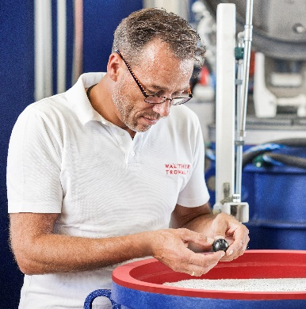
Photo 2: A work piece mounted to the spindle is lowered into the grinding medium.  File name:  Walther Trowal Werkstück vor dem Eintauchen in das Schleifmedium.jpg | 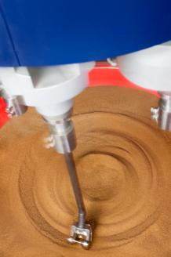
Photo 3: The spindles allow the processing of batches of up to 18 work pieces. For this photo different work pieces were attached to the spindles.  File name:  Walther Trowal Spindel mit verschiedenen Anwendungsbeispielen.jpg | 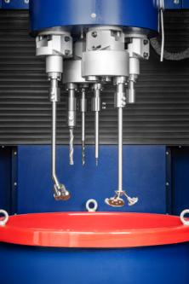
Photo 4: All process steps like cut down, smoothing and polishing take place in the same machine: One work bowl containing a certain medium is removed from the machine with a manual pallet truck and replaced with a bowl containing another medium. This exchange takes place very quickly.  File name:  Walther Trowal Einfacher Wechsel des Schleifmediums.jpg | 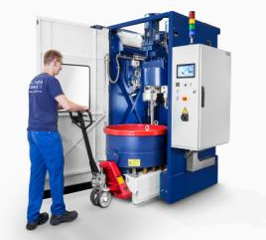
Photo 5: The footprint of the new machines is very compact requiring little floor space.  File name:  Walther Trowal M-TMD 4M.jpg | 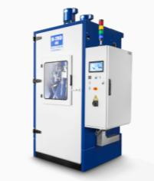
Copyright for the photos: Walther Trowal
Facts about Walther Trowal
For 85 years Walther Trowal has been a pioneer and market leader in various surface treatment technologies. The company offers modular and custom engineered solutions for a wide range of surface treatment problems.
Initially only making vibratory finishing equipment, over the years Walther Trowal has continuously broadened its product range and today offers a wide portfolio of equipment and services for improving all kinds of surfaces, e.g. mass finishing, part cleaning, shot blasting and drying of a wide spectrum of work pieces, last but not least, the coating of mass produced small parts.
Walther Trowal offers not only various types of equipment but complete surface treatment systems: By linking the various equipment modules and automating the complete process, we are able to precisely adapt our process technologies to the technical requirements of our customers. This also includes various types of peripheral equipment and process water cleaning and recycling systems. Of course, we also offer comprehensive pre- and after-sale service like sample processing in one of our demonstration labs and global repair and maintenance service.
Walther Trowal serves many customers in many industries around the world. For example, in the automotive and aerospace industry, medical engineering and wind power generation.
Walther Trowal in America
The recently opened „Tech & Training Centre“ of the Walther Trowal LLC in Grand Rapids, Michigan has, among other equipment, a test lab for the “Trowal Coating” technology allowing interested customers informing themselves about the most suitable coating method for their work pieces.
Trowal has also extended its presence in Latin America by recently opening a sales office in Mexico, which is, of course, using the knowhow and resources of the Grand Rapids facility.

