Facts for the trade press
Surface finishing
Walther Trowal:
Sustainable mass finishing operations
Exchange program ensures that mass finishing equipment is running well over many years.
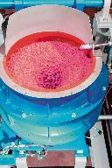
Haan, Germany, October 29, 2019: In September Walther Trowal commissioned a new facility for placing wear linings into new and used work bowls, which are essential components of the company’s mass finishing machinery. With this significant step Walther Trowal practically doubled its capacity for overhauling the work bowls and, thus, guarantees fast turnaround times and high equipment availability for its customers.
Central function of any mass finishing operation is the removal of a small amount of material from the work pieces being processed. However, the downside of this process is that the inside of the work bowl, in which the mix of media and work pieces is moving, is also exposed to a certain amount of wear, especially in case of aggressive grinding operations.
That’s why, for many years, Walther Trowal has been offering a service for the complete refurbishment of worn work bowls. The service not only includes the placement of new wear linings into the work bowls but also a complete inspection of all equipment components and, if necessary, repair welding of the steel fabrications as well as the replacement of worn items with original spare parts. This way the customers can be absolutely sure that after the refurbishment work their mass finishing system is running again as if it was brand new.
The new facility at the company location in Haan was equipped with additional curing ovens allowing the relining of more than 15 work bowls per week. With the installation of a new digital manufacturing control system pass-through times could be significantly reduced resulting in much faster deliveries. Of course, the fact that all casting molds for the various machine types and sizes are in stock and, therefore, immediately available, also helps expediting turnaround times.
Klaus Peter Dose, service manager at Walther Trowal, explains that the refurbishment work is not limited to new wear linings: “If necessary, within the scope of our exchange program we also replace worn machine components. In regular intervals the work bowls are passing through a recycling phase and, therefore, do not have to be scrapped - a prime example for resource saving sustainability in our industry.”
The details of the exchange program
Whenever Walther Trowal receives a work bowl for refurbishment, the job is not just limited to relines: Actually, the customer receives a work bowl that is as good as new with not only a new wear lining but also new equipment components.
Walther Trowal is the only supplier of mass finishing equipment who offers a system signaling the wear rate of a lining. Towards this goal the company is using a method that everybody knows from automobile tires: The lining contains polyurethane cones in a color that is significantly different from the color of the surrounding lining material. Once these cones become visible, the user knows that a refurbishment will soon be required. And the diameter of the visible PU cone provides a good indication of the time frame, within which the bowl must be refurbished. This allows placing a purchase order for an exchange bowl and its on-site delivery without any interruption of the manufacturing operation.
Once a work bowl refurbished by Walther Trowal has been delivered to the customer, the respective mass finishing machine will be up and running again within one or two working days.
Each work bowl received at the Haan facility undergoes a comprehensive inspection that not only covers the wear lining but also the structural integrity of the steel fabrication, all built-in components and, upon customer request, also the drive mechanism.
The refurbishment process starts with the thermal removal of the existing wear lining. Then the work bowl is shot blasted, checked for cracks in the steel fabrication and, if required, repair-welded. For the welding operation Walther Trowal has developed special systems that ensure that the work bowl is not warped. This is extremely important: The vibratory motors mounted to the work bowl generate a high amount of torque that must be absorbed by the steel fabrication. For this reason the motors must be carefully mounted. Even tiny surface irregularities of the mounting flanges, caused by the heat of the welding operation, can cause a catastrophic failure of the vibratory motor mount.
Subsequently, the work bowl is relined. Walther Trowal is one of the few suppliers in the industry who is mixing the polyurethane components in-house and, therefore, can precisely control the wear characteristics of a specific lining with certain additives. Depending on the technical requirements of a given mass finishing process Walther Trowal can process different polyurethane types within a hardness range from 45 to 92 shore A. Of course, a sophisticated documentation system allows tracing every lining material used in any given work bowl.
When it comes to the selection of polyurethane types for work bowl relines, Walther Trowal has always chosen eco-friendly materials with a special focus on work place safety. Since 2012 - long before it became a legal requirement - Walther Trowal has been using mercury-free polyurethane. This means that customers taking advantage of the exchange bowl program, have received work bowls lined with mercury-free polyurethane already since 2012.
Before a refurbished work bowl is dispatched to a customer, worn accessories and components are replaced or repaired. In a last step the machine undergoes a rigorous test to ensure that it is running without any flaws. The overall result: A refurbished product with the characteristics of a new work bowl.
Christoph Cruse, general sales manager at Walther Trowal Walther, considers himself personally responsible for the trouble-free function of the machines: “In the end all functions of the refurbished machine must be working, as if it was brand new. In addition, it must comply with all legal requirements. The refurbishment is not just limited to relines. When we find that a separation flap is worn, we will replace it. Naturally, we only use original spare parts. Since the exchange work bowls are no longer new, after the exchange we provide a one year warranty for the complete work bowl.”
Contact:  Walther Trowal GmbH & Co. KG  Georg Harnau  Rheinische Str. 35-37  42781 Haan, Germany  Phone: +49 2129.571-209  Fax: +49 2129.571-225  www.walther-trowal.de  g.harnau@walther-trowal.de | Contact for the editor:  VIP Kommunikation  The Technological Content Agency  Dr.-Ing. Uwe Stein  Dennewartstraße 25-27  52068 Aachen, Germany  Phone: +49.241.89468-55  Fax: +49.241.89468-44  www.vip-kommunikation.de  stein@vip-kommunikation.de

Photos
Link for downloading photos in print quality:
Click here: press photos Walther Trowal

Photo 1: During the mass finishing process the lining of the work bowl is subject to considerable wear.  File name:  WT_Entgraten_Fliehkraftanlage_RetII.jpg | 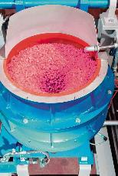
Photo 2: In the new service center all casting molds for the different machine types and sizes are in stock and, therefore, immediately available.  File name:  WT-AT 02.jpg | 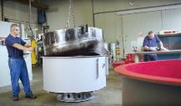
Abb. 3a: A relined work bowl prior to painting.  File name:  20080709WT_265.jpg | 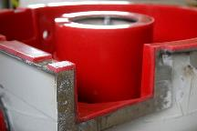
Photo 3b: A relined work bowl prior to painting.  File name:  20080709WT_256.jpg | 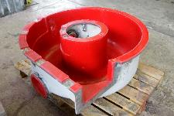
Photo 4: The thickness of the new wear lining is measured and documented.  File name:  WT-AT 05.jpg | 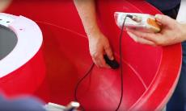
Photo 5: At the end of the lining operation the gaps between moving parts are also checked.  File name:  WT-AT 12.jpg | 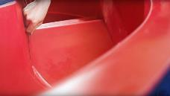
Photo 6: After painting the refurbished work bowls look as good as new.  File name:  WT-AT 09.jpg | 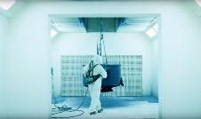
Photo 7: Refurbished work bowls in the final assembly stage.  File name:  WT-Rundvibratoren Montage _1.jpg | 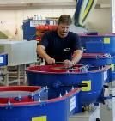
Photo 8: Final assembly of a newly lined work bowl.  File name:  WT-AT 11.jpg | 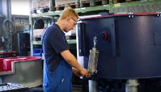
Photo 9: A newly lined and painted work bowl ready for dispatch to the customer.  File name:  WT-AT 14.jpg | 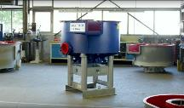

Copyright photos: Company photos Walther Trowal
About Walther Trowal
For 85 years Walther Trowal has been a pioneer and market leader in various surface treatment technologies. The company offers modular and custom engineered solutions for a wide range of surface treatment problems. With more than 12,000 machines installed at customer locations the inventor of the vibratory finishing technology is a global leader in the field of surface treatment.
Initially only making vibratory finishing equipment, over the years Walther Trowal has continuously broadened its product range and today offers a wide portfolio of equipment and services for improving all kinds of surfaces, e.g. mass finishing, part cleaning, shot blasting and drying of a wide spectrum of work pieces, last but not least, the coating of mass produced small parts.
Walther Trowal offers not only various types of equipment but complete surface treatment systems: By linking the various equipment modules and automating the complete process, we are able to precisely adapt our process technologies to the technical requirements of our customers. This also includes various types of peripheral equipment and process water cleaning and recycling systems. Of course, we also offer comprehensive pre- and after-sale service like sample processing in one of our demonstration labs and global repair and maintenance service.
Walther Trowal serves many customers in many industries around the world. For example, in the automotive and aerospace industry, medical engineering and wind power generation.

