Facts for the trade press
Coating of mass-produced small parts made from elastomers
Walther Trowal: The Rotamat coater with new technical features
High quality coating of O-rings or seals in a consistent manner
Haan, Germany, March 24, 2022 At the DKT 2022 exhibition Walther Trowal introduces the new generation of the R 85 Rotamat system for coating mass-produced small parts made from elastomers. Equipped with new spraying technology, precise volume control and integration into the data environment of the users, this coater is ideal for coping with the most challenging coating jobs
New, externally controlled automatic spray guns are evenly applying the coating material onto the surface of the elastomer components. A new sensor continuously measures the material flow with an accuracy of 1/10th gram per minute. This guarantees that the desired amount of coating material is applied onto the surface during the entire process. And it ensures that the desired coating thickness is precisely and consistently achieved.
This makes the Rotamat systems ideally suited for the coating of delicate parts with complex shapes and for tasks, where process safety and consistency are key requirements. Examples for such challenging tasks are coating jobs with two-component coating materials containing pigments or the application of solvent-based lacquers, which must meet particularly stringent quality standards.
A communication processor allows the integration of the Rotamat coaters into higher level production control systems and the industry 4.0 environment of the customers. It also permits the detailed documentation of the entire coating process
Frank Siegel, the sales manager for coating technology at Walther Trowal, explains: „In our new Rotamat 85 system the coating process is now based on precisely measured data. This represents not only a significant improvement of the actual coating operation, but it also is a tremendous help for audits: Our customers can now prove at any time that their production is characterized by a high process safety and consistency of the coating results
Walther Trowal at the DKT 2022 exhibition
June 27 – 30, 2022 in Nuremberg/Germany
Hall 9, Booth number 314
Contact:  Walther Trowal GmbH & Co. KG  Frank Siegel  Rheinische Str. 35-37  42781 Haan/Germany  Tel: +49 2129.571-209  www.walther-trowal.de  f.siegel@walther-trowal.de | Contact for the editor:  VIP Kommunikation  Dr.-Ing. Uwe Stein  Dennewartstraße 25-27  52068 Aachen/Germany  Tel: +49.241.89468-55  www.vip-kommunikation.de  stein@vip-kommunikation.de

Background information
Rotamat systems represent a highly cost-efficient solution for the coating of mass-produced small parts, such as O-rings, handles, springs, or screws. They can be used for a broad range of components made from metal, wood, rubber, or all kinds of plastic.
This includes components for the automotive and cosmetics industry, for toys, stationary goods, and furniture parts as well as seals and shock absorbers. Water- as well as solvent-based lacquers can be processed.
Rotamat systems are equally effective for decorative and functional coatings with numerous water- and solvent-based lacquers as well as for coatings with anti-friction substances, primers, corrosion materials or insulating lacquers.
In Rotamat systems the small parts are coated in a closed, rotating drum. Automatic spray guns are evenly applying the coating material onto the surface of the work pieces, while these are continuously tumbling over each other. The parts are simultaneously dried. This results in an evenly coated surface, a precise coating thickness and a high long-term stability of the coating.
Even delicate components with complex shapes are leaving the machine with an even coating, in single pieces and completely dry! They can be immediately processed in downstream manufacturing operations
The coating process runs fully automatically. All the operator must do, is loading and discharging the drum. The time-consuming and complicated placement of the components on racks, as required with conventional coating systems, is no longer needed.

Photos
Download of photos in printable quality:
Please click here: Pressefotos Walther Trowal
Photo 1: The new, externally controlled automatic spray guns are evenly applying the coating material on the surface of O-rings.  File name:  WT-RA6-2022-0350.jpg | 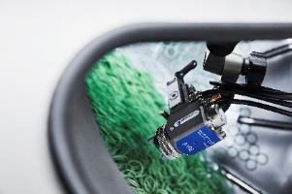
Photo 2: The Rotamat are ideally suited for coating mass-produced small parts made from elastomers, such as O-rings  File name:  WT_Massenkleinteile.jpg | 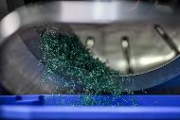
Photo 3: The new Rotamat R 85 with automatic control of the material flow.  File name:  WT-R85C-0421-3079-Gesamt-Person.jpg | 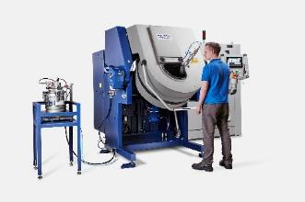
Photo 4: The coated O-rings are leaving the Rotamat system completely dried and can be immediately processed further. File name:  WT-Rotamat-2022-0414.jpg | 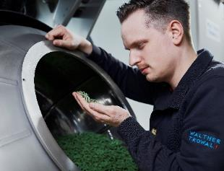
Copyright photos: Walther Trowal

About Walther Trowal
Surface finishing technologies from the inventor of the “Trowalizing” process
Since 1931 Walther Trowal has been developing and producing systems for the refinement of surfaces. Initially focusing exclusively on mass finishing – the term “Trowalizing” originated from the company’s cable address “Trommel Walther” – Walther Trowal has continuously expanded its product portfolio.
Over time the company has developed a broad range of machinery and systems for mass finishing, shot blasting and coating of mass-produced small components.
With the invention of new systems like, for example, drag finishing and the development of special finishing methods for 3D printed components, the company has proven its innovative capabilities repeatedly.
Walther Trowal develops and implements complete surface treatment solutions that can be seamlessly integrated into linked production systems existing at the customers. This includes the entire process technology, perfectly adapted to the specific surface finishing requirements of the work pieces: Equipment and the respective consumables always complement each other in a perfect manner.
Each individual work piece and each manufacturing process must meet special technical requirements. That is why the experienced process engineers in our test lab, in close cooperation with the customers, develop the optimal process technology for the finishing task at hand. The result: Work piece surfaces that meet exactly the required specifications…with short processing times and a high degree of consistent, repeatable results.
Walther Trowal is one of the few manufacturers who develops and produces all machines and mass finishing consumables in-house… including ceramic and plastic grinding and polishing media as well as compounds.
The company’s equipment range also includes all kinds of peripheral equipment for handling the work pieces like lift and tip loaders, conveyor belts and roller conveyors, in addition, special driers for mass finishing applications and, last-but-not-least, systems for cleaning and recycling of the process water.
With its exchange program for wear items like work bowls, which are part of a continuous recycling program, Walther Trowal conserves valuable resources and, thus, makes a significant contribution towards sustainability in the field of industrial production. Quick technical support and the global repair and maintenance service ensure high uptimes for our equipment.
Walther Trowal serves customers in a wide range of different industries all over the world, for example, automotive, aerospace, medical engineering, and wind power.

