Walther Trowal at the
Deburring Expo 2017
Turbotron centrifugal disk finishing machines – gap rinsing allows the gentle finishing of extremely thin work pieces
Haan/Germany, June 26, 2017 Walther Trowal is the first supplier of mass finishing equipment offering TT centrifugal disk finishing machines with rotary spinner and wear ring made from polyurethane and integrated rinsing of the gap between spinner and wear ring.
With the option “gap rinsing” the new Turbotron centrifugal disk machines can now be used for finishing small to midsize, extremely thin fine blanked work pieces. They are equally suitable for deburring, edge radiusing, surface smoothing and polishing. The new machines not only help to lower the initial investment expenses, but with their low wear rate they also contribute to significantly lower operating costs.
Rinsing of the gap (interface) between spinner and wear ring prevents thin work pieces from being wedged between spinner and work bowl. This helps avoid work piece damage and machine crashes. The gap rinsing option now permits using the high energy TT machines for processing very thin parts, which previously had to be finished in conventional mass finishing equipment at much longer cycle times.
At Deburring Expo 2017 Walther Trowal exhibits complete finishing systems including work piece loading & unloading as well as special functions like de-greasing/de-oiling and corrosion protection.
1,100 characters
Walther Trowal at Deburring Expo 2017
(October 10 – 12, 2017 | Messe Karlsruhe/Germany)
Halle 1, Booth 310
Contact:  Walther Trowal GmbH & Co. KG  Georg Harnau  Rheinische Straße 35-37  42781 Haan/Germany  Tel: +49 2129.571-209  Fax: +49 2129.571-225  www.walther-trowal.de  g.harnau@walther-trowal.de | Contact for the editor:  VIP Kommunikation  Dr.-Ing. Uwe Stein  Dennewartstraße 25-27  52068 Aachen/Germany  Tel: +49.241.89468-55  Fax: +49.241.89468-44  www.vip-kommunikation.de  stein@vip-kommunikation.de

About Walther Trowal
For more than 80 years Walther Trowal has been developing, producing and selling modular and custom engineered solutions for a wide range of surface treatment applications.
Starting out with mass finishing systems, Walther Trowal has continuously expanded its product portfolio. Today the company offers a wide range of equipment and services for improving surfaces, for example, mass finishing, cleaning, shot blasting and drying of all kinds of work pieces, as well as coating of mass produced small parts.
Walther Trowal offers not only various types of equipment but complete surface treatment systems: By linking the various equipment modules and automating the complete process, we are able to precisely adapt our process technologies to the technical requirements of our customers. This also includes various types of peripheral equipment and process water cleaning and recycling systems. Of course, we also offer comprehensive pre- and after-sale service like sample processing in one of our demonstration labs and global repair and maintenance service.
Walther Trowal serves many customers in many industries around the world. For example, in the automotive and aerospace industry, medical engineering and wind power generation.

Photos:
Download of photos in print quality: Press photos Walther Trowal
Fig. 1:  In the new TT-centrifugal disk finishing machines the gap (interface) between the (lower) rotating spinner and (upper) stationary work bowl is rinsed with process water.  File name:  Walther Trowal Spaltspülung.jpg | 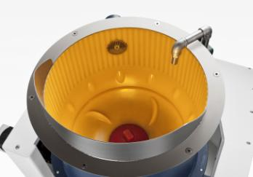
Fig. 2:  Walther Trowal supplies fully automatic systems including work piece loading & unloading. The photo shows a double batch system with magnetic separation.  File name:  Walther Trowal TT_A_2_C (8).jpg | 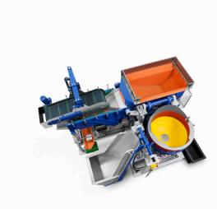
Fig. 3:  Before and after: A 0.15 mm thick weaving heddle before (left) and after processing in a TT machine (right).  File name:  Walther Trowal Dünnes Werkstück_3.jpg | 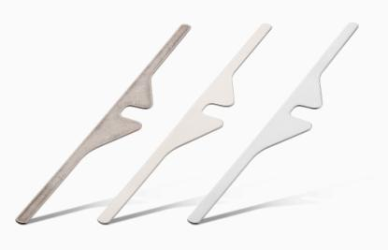
Copyright photos: Walther Trowal

