Facts for the trade press
Mass finishing, deburring, polishing, shot blasting and coating
Walther Trowal opens the „North American Tech & Training Centre“
The branch in Michigan now has its own process development center and offers comprehensive service for North- and South-America
Haan, Germany, April 16, 2018 To cope with the increasing business volume in the Americas and to better serve the American customers in the field of surface finishing and preparation, Walther Trowal is expanding its sales branch in Grand Rapids, established in 2005, with additional manpower and a process development lab. Recently the Walther Trowal LLC has officially opened its “North American Tech & Training Center”.
The company, initially established as a sales office, has become an operation with its own test center, after-sales service activities and a sizable warehouse for compounds, media and spare parts. Effective immediately two recently hired application and sales engineers, stationed in Grand Rapids, are now supporting the already existing nine distributors in the US and Mexico, including our sales office in Querétaro, Mexico.
Moreover, the newly established process development lab, equipped with a range of different finishing machines, now offers American customers the possibility to test the Walther Trowal equipment with their work pieces directly in the United States and to optimize their finishing processes.
Ken Raby, Vice President and General Manager of the Walther Trowal LLC, is now in a position to serve his North-American customers even better: „We consider close proximity to our customers as essential to our future success. With our expanding sales and technical base in Grand Rapids we can adapt our processes and systems much better and, especially, much faster to the requirements of the American users. Especially in the field of mass finishing it is essential to develop and optimize the various finishing processes for our customers through processing trials under manufacturing conditions in our test lab”.
The new „Tech & Training Centre“ is also equipped with a lab for coating technology. This allows the customers to test various coating methods and develop the right process for their coating requirements with the “Trowal Coating” technology.
Christoph Cruse, general sales manager at Walther Trowal in Haan, explains why the company is expanding its presence in North-America: „The North-American market is somewhat different from Europe – Especially in the United States the automobile industry is still a key player, but is subject to enormous cost pressures. That is why it is essential for us to offer our customers fast and competent service. Long reaction or downtimes are no longer acceptable! In addition, we also see a tremendous potential in the rapidly expanding aerospace industry and medical engineering.“
In Latin America Walther Trowal has also expanded its presence with the recently opened sales office in Queretaro, Mexico. The local staff is supported by the knowhow and service of the colleagues in Grand Rapids.
The capacity of the new, large warehouse ensures that the Walther Trowal LLC can offer short delivery times for equipment and consumables. The mass finishing, shot blasting and coating equipment as well as the plastic finishing media are still supplied from the Walther Trowal headquarters in Germany. Ceramic media continue to be manufactured at the plant in Stoke-on-Trent, Great Britain.
490 words including introduction
Contact in Germany:  Walther Trowal GmbH & Co. KG  Georg Harnau  Rheinische Str. 35-37  42781 Haan/Germany  Tel: +49.2129.571-209  Fax: +49.2129.571-225  www.walther-trowal.de  g.harnau@walther-trowal.de | Contact for the editor:  VIP Kommunikation  Dr.-Ing. Uwe Stein  Dennewartstraße 25-27  52068 Aachen/Germany  Tel: +49.241.89468-55  Fax: +49.241.89468-44  www.vip-kommunikation.de  stein@vip-kommunikation.de
Contact in the United States:
Walther Trowal LLC
Victoria Mathews
4540 East Paris Avenue SE, Suite F
Grand Rapids, MI 49512, USA
Tel.: +1.616.455 8940
Fax: +1.616.871 0037
www.walther-trowal.com
V.Mathews@walther-trowal.com

Photos:
Download of photos in print quality:
Please click here: Photos Walther Trowal
Photo 1: The Test & Training Centre in Grand Rapids.  File name:  Walther Trowal IMG_3446.jpg | 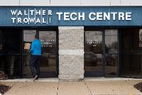
Photo 2: In the Test & Training Center: Loading of work pieces into a CF rotary vibrator for processing.  File name:  Walther Trowal IMG_3247.jpg | 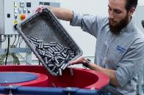
Photo 3: The Test & Training Centre in Grand Rapids is equipped with a Rotamat coater for coating of mass produced small parts.  File name:  Walther Trowal IMG_3290.jpg | 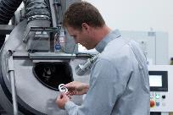
Photo 4: Processes with different types of media can be tested quickly in the new test lab.  File name:  Walther Trowal IMG_3403.jpg | 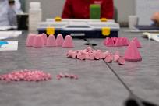
Photo 5: Ken Raby, Vice President and General Manager of Walther Trowal LLC  Dateiname:  Walther Trowal KenatMachine.jpg | 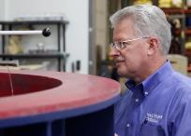
Photo 6: Victoria Mathews, internal sales support manager, conducting a training for media and compounds  File name:  Walther Trowal IMG_3297.jpg | 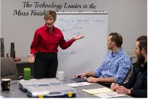
Copyright all photos: Walther Trowal
Facts about Walther Trowal
For more than 85 years Walther Trowal has offered modular and custom engineered solutions for a wide range of surface treatment problems.
Initially only making vibratory finishing equipment, over the years Walther Trowal has continuously broadened its product range and today offers a wide portfolio of equipment and services for improving all kinds of surfaces, e.g. mass finishing, part cleaning, shot blasting and drying of a wide spectrum of work pieces, last but not least, the coating of mass produced small parts.
Walther Trowal offers not only various types of equipment but complete surface treatment systems: By linking the various equipment modules and automating the complete process, we are able to precisely adapt our process technologies to the technical requirements of our customers. This also includes various types of peripheral equipment and process water cleaning and recycling systems. Of course, we also offer comprehensive pre- and after-sale service like sample processing in one of our demonstration labs and global repair and maintenance service.
Walther Trowal serves many customers in many industries around the world. For example, in the automotive and aerospace industry, medical engineering and wind power generation.

