Facts for the trade press for the Deburring Expo 2021
Surface refinement with the mass finishing technology

Walther Trowal:
New abrasive mineral creates smooth, shiny surface finishes
Longer usable life of grinding media and compounds improves operational sustainability
Haan, Germany, September 17, 2021 At this year’s Deburring Expo Walther Trowal presents its new plastic grinding media AF to the public for the first time. The company developed the AF media specifically for finishing high-value work pieces made from metal, for example, turbine blades for jet engines, stampings for the automotive industry or medical implants. During deburring operations a new grinding mineral generates particularly smooth, pre-plate finishes as well as a high luster on the work pieces.
For the new media the experts at the Walther Trowal chemical lab developed an innovative abrasive mineral that is maintaining the pH value of the process water over long time periods. This ensures the optimal functionality of the compound. An additional effect is that an increase of the pH value through orthosilicic acid is prevented. Therefore, the pH value must no longer be monitored, and the correction with additional buffer chemicals has been completely eliminated: The dosing of the compound is now very simple and requires no special knowledge.
Angelika Helten, manager of the test lab at Walther Trowal, explains why Walther Trowal’s investment in the new media was so important: „In some high-performance finishing applications certain physical processes cause the pH value of the process water to decline over time. With the new media we could develop a long-term, sustainable solution, which no longer requires the addition of corrective chemicals. This is also beneficial to customers, who are dealing with less challenging finishing tasks. For, apart from keeping the pH value stable, the AF media offers other advantages”.
Since the new abrasive mineral wears at an exceptionally slow rate, the usable life of the media could be significantly prolonged. For this reason, the new AF media contributes to a higher cost-efficiency of the mass finishing operations.
Walther Trowal at the Deburring Expo 2021:
Location and time: Karlsruhe, October 12 – 14, 2021
Hall 1, Booth 410
Contact:  Walther Trowal GmbH & Co. KG  Georg Harnau  Rheinische Straße 35-37  42781 Haan, Germany  Tel: +49 2129 571-209  www.walther-trowal.de  g.harnau@walther-trowal.de | Contact for the editor:  VIP Kommunikation  Dr.-Ing. Uwe Stein  Dennewartstraße 25-27  52068 Aachen, Germany  Tel: +49 241 89468-55  www.vip-kommunikation.de  stein@vip-kommunikation.de
Photos
Download of the high solution picture files: Pressefotos Walther Trowal
Photo 1: The new AF media generates particularly smooth, pre-plate finishes as well as a high luster on high-value work pieces.  File name:  WT_Schleifmittel_AF-0621-4644.jpg | 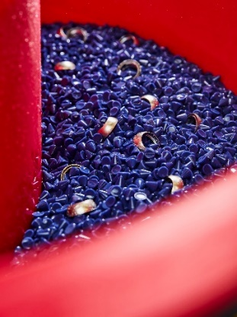
Photo 2: The new media, developed in the Trowal chemical lab, produces not only smooth, shiny finishes, but it also maintains the pH value of the process water over a long time period.  File name:  WT_Schleifmittel-Produktion-0621-4584.jpg | 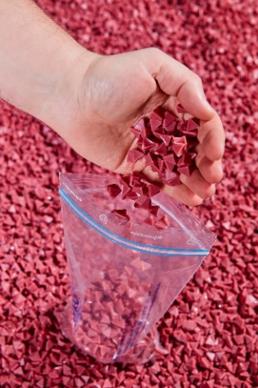
Photo 3: Final quality control of the media prior to shipment.  File name:  WT_Schleifmittel-Produktion-0621-4543a.jpg | 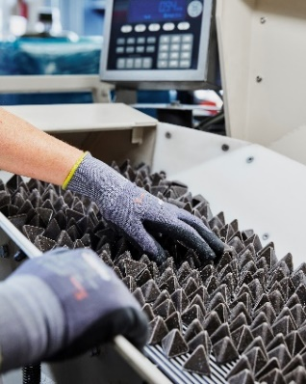
Copyright photos: Walther Trowal
About Walther Trowal
Surface finishing technologies from the inventor of the “Trowalizing” process
Since 1931 Walther Trowal has been developing and producing systems for the refinement of surfaces. Initially focusing exclusively on mass finishing – the term “Trowalizing” originated from the company’s cable address “Trommel Walther” – Walther Trowal has continuously expanded its product portfolio.
Over time the company has developed a broad range of machinery and systems for mass finishing, shot blasting and coating of mass produced small components.
With the invention of new systems like, for example, drag finishing and the development of special finishing methods for 3D printed components, the company has proven its innovative capabilities again and again.
Walther Trowal develops and implements complete surface treatment solutions that can be seamlessly integrated into linked production systems existing at the customers. This includes the entire process technology, perfectly adapted to the specific surface finishing requirements of the work pieces: Equipment and the respective consumables always complement each other in a perfect manner.
Each individual work piece and each manufacturing process must meet special technical requirements. That is why the experienced process engineers in our test lab, in close cooperation with the customers, develop the optimal process technology for the finishing task at hand. The result: Work piece surfaces that meet exactly the required specifications…with short processing times and a high degree of consistent, repeatable results.
Walther Trowal is one of the few manufacturers who develops and produces all machines and mass finishing consumables in-house… including ceramic and plastic grinding and polishing media as well as compounds.
The company’s equipment range also includes all kinds of peripheral equipment for handling the work pieces like lift and tip loaders, conveyor belts and roller conveyors, in addition, special driers for mass finishing applications and, last-but-not-least, systems for cleaning and recycling of the process water.
With its exchange program for wear items like work bowls, which are part of a continuous recycling program, Walther Trowal conserves valuable resources and, thus, makes a significant contribution towards sustainability in the field of industrial production. Quick technical support and the global repair and maintenance service ensure high uptimes for our equipment.
Walther Trowal serves customers in a wide range of different industries all over the world, for example, automotive, aerospace, medical engineering and wind power.

