Facts for the trade press
Surface refinement of castings or stampings
A novelty at the AMB trade show:
For the first time Walther Trowal displays shot blast machinery at the show
Haan/Germany, July 18, 2022 At the AMB trade show Walther Trowal displays not only mass finishing but also shot blasting equipment for blast cleaning of castings and stampings. The new troughed belt shot blast machine is characterized by its small footprint, and the TT high-energy mass finishing system requires 20% less energy.
The new tumble belt shot blast machine can be seamlessly integrated into manufacturing operations
At the AMB trade show Walther Trowal introduces the compact continuous flow troughed belt shot blast machine, model THM 300/1. This machine was specifically developed for treating high volumes of small, delicate work pieces with thin walls. It can handle aluminum and zinc die-castings with diagonal measurements between 20 and 150 mm. For example, this includes toy cars, components for consumer electronics or fittings for the furniture industry.
For the first time a continuous flow shot blast machine is now available for treating small work pieces. With a footprint of only 1.4 x 2.7 meters it can be easily integrated into existing manufacturing lines.
With the unique troughed belt transport system the work pieces are gently passing through the machine in a spiral movement. Since the work pieces are continuously tumbling over each other, they are evenly blasted on all sides.
Meik Seidler, sales manager shot blasting at Walther Trowal recognizes a distinct shot blasting trend: „The THM continuous flow blast machines with their unique troughed belt transport system can be easily integrated into interlinked manufacturing processes. They are increasingly replacing conventional batch blast systems. The raw work pieces are entering the machine at the same cycle at which they are produced. This eliminates the transport from one manufacturing stage to the next, and intermediate storage is no longer necessary.”
Potential customers who see the displayed machines at the exhibition, can conduct processing trials with their work pieces at the new test and training centers in Haan, Germany, and in Grand Rapids/Michigan, USA.
New Turbotron centrifugal disk finishing machine requires up to 20 % less energy
With new energy-efficient electric motors Walther Trowal succeeded in lowering the energy consumption of its Turbotron centrifugal disk finishing machines TT 90…A/2C by up to 20%. These high-intensity systems allow the fast deburring, edge radiusing, surface smoothing and, even, polishing of small to mid-size work pieces.
With the new option “gap rinsing and automatic gap setting” these machines are ideal for finishing extremely thin precision stampings. The pressure created by the gap rinse feature prevents thin-walled work pieces from migrating into the interface (gap) between the rotating spinner and the stationary work bowl.
Christoph Cruse, general sales manager at Walther Trowal, identifies more benefits for his customers: „Contrary to traditional centrifugal disk finishing machines the TT systems are working with a high-water level in the work bowl, whenever thin work pieces must be deburred and smoothed. This prevents them from sticking to each other or adhering to the work bowl wall.”
Walther Trowal offers the new Turbotron systems with the “gap rinsing” option as stand-alone machines with manual work piece loading and unloading as well as larger, fully automatic systems with integrated loading device, vibratory screening device and media return unit.
520 words including introduction
Walther Trowal at the AMB 2022
Stuttgart, September 13 – 17, 2022
hall 5, booth A43
Contact:  Walther Trowal GmbH & Co. KG  Georg Harnau  Rheinische Straße 35-37  42781 Haan/Germany  Tel: +49 2129.571-209  www.walther-trowal.de  g.harnau@walther-trowal.de | Contact for the editor:  VIP Kommunikation  Die Content-Agentur für die komplexen Technik-Themen  Dr.-Ing. Uwe Stein  Dennewartstraße 25-27  52068 Aachen/Germany  Tel: +49.241.89468-55  www.vip-kommunikation.de  stein@vip-kommunikation.de

Photos:
Download of the photos in print quality:
Please click here: Pressefotos Walther Trowal
Photo 1: With the unique troughed belt transport system the work pieces are gently passing through the machine.  File name:  WT_THM_3001_Transportsystem.jpg | 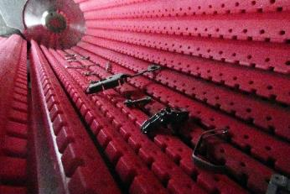
Photo 2: Continuous flow troughed belt shot blast machine THM 300/1: With a footprint of only 1.4 x 2.7 meters the machine can be easily integrated into existing manufacturing lines.  File name:  WT_THM_300_400_10_trowal_0081.jpg | 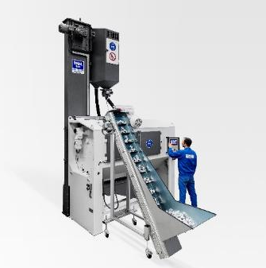
Photo 3: Turbotron centrifugal disk finishing machine TT 90…A/2C: The gap rinse feature prevents thin work pieces from migrating into the interface (gap) between the rotating spinner (yellow) and the stationary work bowl (red).  File name:  WT_TT_A_2_C (8).jpg | 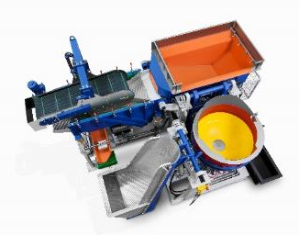
Photo 4: Turbotron centrifugal disk finishing machine TT 90…A/2C: The centrifugal force of the spinner forces the mix of media and work pieces to move up the wall of the work bowl. Gravity forces the mix to fall back onto the spinner.  File name:  WT_20080828_060.jpg | 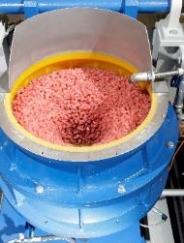
Copyright photos: Walther Trowal

Technical background: Gentle work piece transport in THM troughed belt shot blast machines
The THM continuous flow troughed belt shot blast machines can handle high volumes of mass-produced parts as well as complex, delicate single components. Because of their simple work piece handling and better shot blast results, they increasingly replace conventional batch tumblast systems.
The THM continuous flow blast machines are especially beneficial for treating delicate work pieces: In the troughed belt the individual work pieces are not colliding but simply touch each other gently. The work pieces are not falling on top of each other but are softly tumbling over the polyurethane coating of the transport rods. Since today increasingly highly delicate parts are being manufactured, the gentle work piece handling in the THM machines is particularly advantageous. It ensures that the finished work pieces are leaving the shot blast machine without any blemishes such as nicks or dents.
Compared to spinner hanger shot blast machines the continuous flow troughed belt machines have also clear advantages. This is especially the case with large work pieces with complex shapes: During the transport through the troughed belt the work pieces are rotating. This ensures that the thrown blast media Is reaching all surface areas, and always at the same distance from the blast turbine(s). This ensures all-around homogeneous shot blast results.

Technical background:
Surface finishing with Turbotron centrifugal disk machines
The high processing intensity, typical for the Walther Trowal centrifugal disk finishing machines, is achieved through the intensive “rubbing” of the media against the work pieces and the high pressure of the media against the work piece surface generated by the centrifugal force.
In the lower part of the machine a spinner rotates at speeds between 60 and 250 RPM. The centrifugal force generated by the spinner rotation drives the media/work piece mix up the inner wall of the stationary work bowl. As the centrifugal force diminishes, gravity forces the media/work piece mix to fall back onto the rotating spinner, where it is accelerated again.
About Walther Trowal
Surface finishing technologies from the inventor of the “Trowalizing” process
Since 1931 Walther Trowal has been developing and producing systems for the refinement of surfaces. Initially focusing exclusively on mass finishing – the term “Trowalizing” originated from the company’s cable address “Trommel Walther” – Walther Trowal has continuously expanded its product portfolio.
Over time the company has developed a broad range of machinery and systems for mass finishing, shot blasting and coating of mass-produced small components.
With the invention of new systems like, for example, drag finishing and the development of special finishing methods for 3D printed components, the company has proven its innovative capabilities again and again.
Walther Trowal develops and implements complete surface treatment solutions that can be seamlessly integrated into linked production systems existing at the customers. This includes the entire process technology, perfectly adapted to the specific surface finishing requirements of the work pieces: Equipment and the respective consumables always complement each other in a perfect manner.
Each individual work piece and each manufacturing process must meet special technical requirements. That is why the experienced process engineers in our test lab, in close cooperation with the customers, develop the optimal process technology for the finishing task at hand. The result: Work piece surfaces that meet exactly the required specifications…with short processing times and a high degree of consistent, repeatable results.
Walther Trowal is one of the few manufacturers who develops and produces all machines and mass finishing consumables in-house… including ceramic and plastic grinding and polishing media as well as compounds.
The company’s equipment range also includes all kinds of peripheral equipment for handling the work pieces like lift and tip loaders, conveyor belts and roller conveyors, in addition, special driers for mass finishing applications and, last-but-not-least, systems for cleaning and recycling of the process water.
With its exchange program for wear items like work bowls, which are part of a continuous recycling program, Walther Trowal conserves valuable resources and, thus, makes a significant contribution towards sustainability in the field of industrial production. Quick technical support and the global repair and maintenance service ensure high uptimes for our equipment.
Walther Trowal serves customers in a wide range of different industries all over the world, for example, automotive, aerospace, medical engineering and wind power.

