Facts for the trade press
Deburring, edge radiusing, surface smoothing and polishing of mass-produced work pieces
Gentle finishing of extremely thin work pieces with Turbotron centrifugal disk finishing machines
Rotary spinner made from polyurethane reduces operating costs
Haan/Germany, May 16, 2017 With the innovative option “gap rinsing” the new Turbotron centrifugal disk finishing machines from Walther Trowal are ideal for finishing extremely thin fine-blanked parts. The new machines lower the investment expenditures and offer high uptimes.
Walther Trowal is the first supplier of mass finishing equipment who brings a new line of TT centrifugal disk finishing machines to the market with spinner and wear ring completely made from polyurethane and a rinsing system for the gap between spinner and stationary work bowl. This system prevents thin parts getting caught in the gap and get damaged. The new TT machines are a cost effective, highly wear resistant alternative to conventional mass finishing machines, especially for processing very thin work pieces.
To date the removal of burs and radiusing of edges on thin, relatively small parts required the use of centrifugal disk machines with special spinners made from ceramic or tungsten carbide steel. To prevent thin parts getting caught in the gap between the rotating spinner and stationary work bowl the precise setting of the gap was crucial for achieving the required finishing results.
Since even minor damage of the delicate spinner could result in high repair costs, the engineers at Walther Trowal were looking for a more economic solution.
The recently developed gap rinsing system now allows utilizing the spinners and wear rings Walther Trowal has been employing in large quantities in its standard centrifugal disk machines. This helps to drastically reduce the equipment expenditures, because PU is much less complicated to handle than, for example, ceramic materials. In addition, the gap size can be easily adjusted with the proven standard gap setting system. The pressure created by the rinsing system ensures that thin parts can no longer be drawn into the gap between spinner and wear ring.
Contrary to other mass finishing systems for deburring and grinding of thin components the new disk machines are operating with high water level in the work bowl. This helps prevent the work pieces from sticking to each other or clinging to the wall of the work bowl.
Christoph Cruse, general sales manager at Walther Trowal, sees significant benefits for his customers: “ Our new machines represent an economic, low-wear solution. Ceramic materials used to date are relatively brittle and can easily chip! This can cause costly damage to spinner and wear ring. Since we have worked with polyurethane for many years, we are very familiar with this material. To come to the heart of the matter: We have developed a smart, cost effective solution that works great for our customers.”
Walther Trowal offers the option “gap rinsing” across the complete range of Turbotron disk finishing machines, from simple stand-alone units with manual work piece loading and unloading to large, fully automatic systems with hydraulic loader, external vibratory screening machine and media return conveyor.
470 words including introduction
Background:
Surface finishing with Turbotron centrifugal disk finishing machines
The high processing intensity, typical for the Walther Trowal centrifugal disk finishing machines, is achieved by the highly intensive interaction between processing media and work pieces and the high pressure of the media on the work piece surface created by the centrifugal force of the rotating spinner.
The spinner rotates with a speed of between 60 and 250 U/min. The centrifugal force created by this movement pushes the mix of work pieces, media and process water up the inner wall of the stationary work bowl. Once it has lost its kinetic energy the work piece/media mix collapses back to the spinner, from where it is accelerated again.
Background: 100 words
Contact:  Walther Trowal GmbH & Co. KG  Christoph Cruse  Rheinische Str. 35-37  42781 Haan/Germany  Fon: +49 2129.571-207  Fax: +49 2129.571-225  www.walther-trowal.de  c.cruse@walther-trowal.de | Contact for the editor:  VIP Kommunikation  Dr.-Ing. Uwe Stein  Dennewartstraße 25-27  52068 Aachen/Germany  Fon: +49.241.89468-55  Fax: +49.241.89468-44  www.vip-kommunikation.de  stein@vip-kommunikation.de

Photos
Download of photos in print quality: Press photos Walther Trowal
Abb. 1: In the new TT centrifugal disk finishing machines the gap created between rotating spinner (bottom) and stationary work bowl (top) is continuously rinsed with process water.  File name:  Walther Trowal Spaltspülung.jpg | 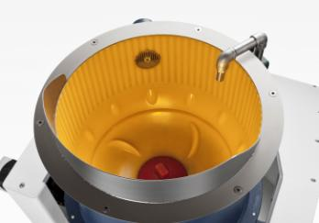
Abb. 2: Walther Trowal offers fully automatic systems with work piece loading and unloading; the photo shows a double batch system with magnetic separation.  File name:  Walther Trowal TT_A_2_C (8).jpg | 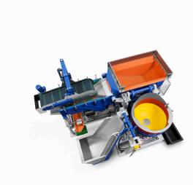
Abb. 3: Before and after: A 0.15 mm thick weaving heddle before (left) and after (right) in a TT machine.  File name:  Walther Trowal Dünnes Werkstück_3.jpg | 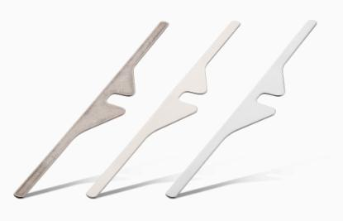
Abb. 4: Before and after: Knife blades before (left) und after (right) polishing in a TT machine. These work pieces require a particularly smooth, shiny surface.  File name:  Walther Trowal Dünnes Werkstück_2.jpg | 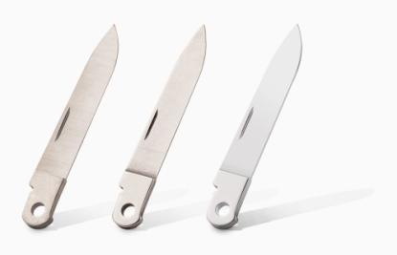
Photo rights: Company photos Walther Trowal
About Walther Trowal
Since 1931 Walther Trowal develops, produces and sells modular and custom engineered solutions for a wide range of surface treatment applications.
Starting out with mass finishing systems, Walther Trowal has continuously expanded its product portfolio. Today the company offers a variety of equipment and services for improving surfaces, for example, mass finishing, cleaning, shot blasting and drying of all kinds of work pieces, as well as coating of mass produced small parts.
Walther Trowal offers not only various types of equipment but complete surface treatment systems: By linking the various equipment modules and automating the complete process, we are able to precisely adapt our process technologies to the technical requirements of our customers. This also includes various types of peripheral equipment and process water cleaning and recycling systems. Of course, we also offer comprehensive pre- and after-sale service like sample processing in one of our demonstration labs and global repair and maintenance service.
Walther Trowal serves many customers in many industries around the world. For example, in the automotive and aerospace industry, medical engineering and wind power generation.

